KIP and Friends
Learning at Home: A4 (a)

Pentecost

How to use this workbook!

What I think about your ‘work at home’ time!

I think you will have either a book to work in at home, or some paper to work on. I think you will have pencils or pens to write with and maybe some coloured pencils.
I also think you will have access to the internet.

You might have a printer and glue and scissors.
If you have a printer you can print this book off and do the activities using the pages in it, or cut out the pictures and paste them into your book.
If you don’t have a printer, copy what you need into your workbook.

You will need to choose what activities you can do and which ones you can’t! Easier activities are listed first.

This workbook is to help you learn:

1. How Christians and Jews celebrate Pentecost (Shavu’ot)

The information is in red: the activities are in black

Last workbook you learned about what we do in Church to celebrate the last week of the life of Jesus. This workbook teaches you about the next event we remember in the Church: Pentecost, or the coming of the Holy Spirit.

Pentecost (Shavu’ot) in the time of Jesus.

Some things to do! (younger pupils)

The next major festival we celebrate in the Church is Pentecost. It is called Pentecost as it is always celebrated 50 days after Easter (‘penta’ is the Greek word for 5). This year Pentecost is on May 31st. It is Year A this year and Matthew does not have an account of Pentecost so we need to go to Luke, to hear what happened. In his account Luke tells us that the spirit comes among the disciples gathered in Jerusalem for the festival, giving them all the gift of speech.
1. Draw a pentagon in your book. It has to have five sides… like this one.

2. Watch this video of Pentecost to get an idea of what happened.
https://www.youtube.com/watch?v=xtokHQOmFu0

Some things to do! (older pupils)

1. Draw a pentagon in your book.
2. Read what Luke tells us happened. Look carefully for where everyone is (the setting) and who is there (the characters). Read twice if you want to!
‘When the day of Pentecost had come, they were all together in one place. ²And suddenly from heaven there came a sound like the rush of a violent wind, and it filled the entire house where they were sitting. ³Divided tongues, as of fire, appeared among them, and a tongue rested on each of them. ⁴All of them were filled with the Holy Spirit and began to speak in other languages, as the Spirit gave them ability.
5 Now there were devout Jews from every nation under heaven living in Jerusalem. ⁶And at this sound the crowd gathered and was bewildered, because each one heard them speaking in the native language of each. ⁷Amazed and astonished, they asked, ‘Are not all these who are speaking Galileans? ⁸And how is it that we hear, each of us, in our own native language?’

3. Draw what happens, according to Luke, in your pentagon.

Some things to do! (younger and older pupils)

1. Draw another pentagon!

Luke tells us that the festival we call Pentecost was actually a Jewish festival called Shavu’ot. It was a festival which thanked God for the gift of both the first fruits and crops of the season and for the gift of the Torah (The first 5 books of Jewish scripture). Israelites from all around would gather in Jerusalem and bring with them the very first fruits and crops of the season, to give as a gift to God at the Temple.

2. Look at this image of people gathering together to celebrate Shavu’ot in the time of Jesus. The Temple (where the offering of first fruits would be made) is the big building just inside the city walls.
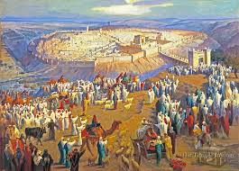

https://www.facebook.com/templeinstitute/photos/a.86889944968/10151205793679969/?type=1&theater

3. Watch this video of a re-enactment of Shavu’ot https://www.youtube.com/watch?v=7ugvJSYnXXI

4. Now draw how the Jewish people celebrated Shavu’ot at the Temple in your second pentagon. Draw them gathering at the Temple with baskets of their first fruits.

Jews today can’t go to the Temple anymore because it was destroyed in a war between the Jews and the Romans (who occupied the land) in the year 70. The festival is still remembered though.

How do Jews celebrate Shavu’ot now?

This information is taken from this website:
https://www.chabad.org/library/article_cdo/aid/4027637/jewish/Eleven-Shavuot-Facts-Every-Jew-Should-Know.htm

Shavu’ot is celebrated over two days. The festival has 5 names!
Shavuot: The word Shavuot means weeks. It marks the seven weeks between Passover and Shavuot.
Yom HaBikkurim: ‘The day of First Fruits.’ Shavu’ot is also the celebration of the wheat harvest and the ripening of the first fruits.
Chag HaKatzir: The ‘Harvest Festival.’ Because Jews harvest the ripening fruits to eat!
Atzeret: ‘The Stoppage’. You are not allowed to work on this holy day.
Zeman Matan Torahteinu: In the holiday prayer service, we refer to Shavu’ot as the ‘Time of the Giving of Our Torah.’

Here are five pieces of information about how Jews today celebrate Shavu’ot.

1. Women and girls light candles to welcome the holy day on both of its evenings.

2. It is a custom for people to stay up and learn the Torah on the first night of Shavuot.

3. Everyone listens to the reading of the Ten Commandments on the first day of Shavuot.
4. Some Jews decorate their homes with flowers to get ready for Shavuot.

5. It is a custom for people to eat dairy foods on Shavuot.

Some things to do! (younger pupils)

1. Draw yet another pentagon! Divide it into 5 sections (like this one). Draw how modern Jews remember the festival of Shavu’ot: one practice in each section.

Some things to do! (older pupils)

1. Look at this website. https://www.chabad.org/library/article_cdo/aid/4027637/jewish/Eleven-Shavuot-Facts-Every-Jew-Should-Know.htm
Find more information about each of the 5 things Jews do, draw and write it into a pentagon, like the one above.

2. Make a list of some of the other things Jews do to celebrate Shavu’ot in their homes now.

How do Catholics celebrate Pentecost now?

Although we don’t have a special action for Pentecost, the Church will be decorated to remind us of Pentecost. The symbols of the Holy Spirit are a dove, fire and wind and you may see those on banners in the Church. The Priest will wear red and the altar cloth will be red. The prayers on Pentecost Sunday all talk about the coming of the spirit as well.

Here are some Pentecost banners. These contain symbols we use to remember and think of the Holy Spirit.
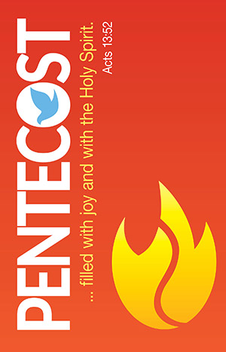
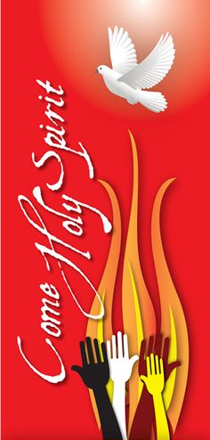

1.
Some things to do! (younger pupils)

1. Trace your hand onto the bottom of a page in your book. Trace the hands of the other people in your home as well. (like the middle banner)

2. Colour in the hands using the colours of Pentecost: reds, yellows, oranges…

3. Copy this prayer to the Holy Spirit above your hands.
Come, Holy Spirit, fill our hearts with your love.

Some things to do! (older pupils)

1. Read some of the prayers we say on Pentecost Sunday.

a. The entrance antiphon, which we say as we walk in, says…

‘The love of God has been poured into our hearts through the Spirit of God dwelling within us, alleluia.’

b. The psalm, after the first reading says…

‘Lord, send out your Spirit and renew the face of the earth.’

c. The gospel acclamation, which we say as we stand to welcome the Gospel, says
Alleluia, alleluia!
Come, Holy Spirit, fill the hearts of your faithful and kindle in them the fire of your love.
Alleluia!

2. Watch and listen to this song called Come Holy Spirit, by Tony Yu: https://www.youtube.com/watch?v=K_WOFqap0oM

Here are the lyrics

Verse
Come Holy Spirit and fill my heart
Come Holy Spirit set me apart
Come Holy Spirit to you I pray
Come Holy Spirit show me the way

Come Holy Spirit and heal me now
Come Holy Spirit and melt me now
Come Holy Spirit and mold me now
Come Holy Spirit and use me now

Chorus
Pour out your grace upon this place
I feel your healing touch in your warm embrace
Renew my life Lord Jesus Christ
That I may bring your love and peace to all the earth

3. During Pentecost we pray that the Holy Spirit will come into our lives (our hearts and minds) and inspires and strengthens us to that we might make our world better; fill it with God’s love.

Draw a banner for Pentecost Sunday (look at the three above) and write a prayer asking God to send His spirit to us this Pentecost!

