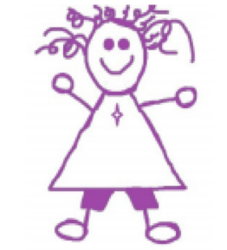
In God’s Name
The companion Religious Education programme for KIP and Friends
written by: Dr. Margaret Carswell
EYFS
Branch 5 – To the Ends of the Earth
Summer 1

This unit teaches the EYFS outcomes named in the Religious Education Directory (2022) for Branch 5.
Should you wish to subscribe to In God’s Name please email margaretfcarswell@gmail.com
This work is copyright

To the Ends of the Earth
In a nutshell!

The content areas:
Catholic belief (Believe Lens) is very evident in the events that are remembered in the Season of Easter.
- That Jesus rose from the dead and met with the disciples after the resurrection
- That Jesus gave up his bodily form and became pure spirit
- That the Holy Spirit, promised by Jesus in his lifetime, came to the community
- That the early followers formed a community which eventually developed into the Church
Each of these beliefs is complex but at a simple level they all find their essence in the events which children hear and celebrate in the Easter Season.
Lent allows Catholics to live in preparation for Easter.

- The Season of Easter (Hear Lens)
  - The walk to Emmaus (additional text)
  - The Ascension
  - Pentecost
  - The early community

- How we celebrate the Season of Easter (Celebrate Lens)
- Living the new life of Easter. (Live Lens)

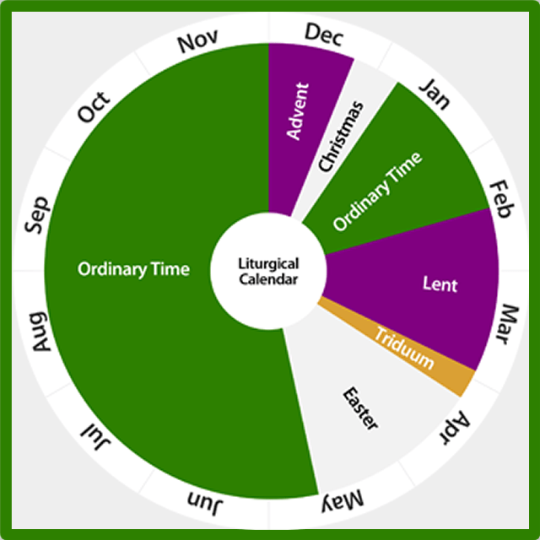

KEY INFORMATION for TEACHERS
The Scripture Passages
This branch has three scripture passages named for study in the RED the Ascension, Pentecost and life of the earliest community.
An additional passage is also included by me, for you – the walk to Emmaus. You may have done this passage last half term, if so, just refresh it.
Together the passages answer the question, what happened after the resurrection as the Church went ‘to the ends of the earth’?

Where I have been able to, I have used the versions of these passages found in the Children’s lectionary.

The walk to Emmaus: Luke 24:13-35 (Adapted from NRSV)
¹³ Now on that same day two disciples were going to a village called Emmaus, about seven miles^{[a]} from Jerusalem, ¹⁴ and talking with each other about all the things that had happened. ¹⁵ While they were talking and discussing, Jesus himself came near and went with them, ¹⁶ but they did not recognise him. ¹⁷ And Jesus said to them, “What are you talking about as you walk along?” They stood still, looking sad.^{[b]} ¹⁸ Then one of them, whose name was Cleopas, answered him, “Are you the only stranger in Jerusalem who doesn’t what has happened here? ¹⁹ He asked them, “What things?” They replied, “The things about Jesus of Nazareth,^{[c]} who was a prophet, mighty in deed and word before God and all the people. ²⁰ Our chief priests and leaders handed him over to be condemned to death and crucified him. ²¹ We had hoped that he was the one to save us.^{[d]} Yes, and besides all this, it is now the third day since these things took place. ²² Some women in our group astounded us. They were at the tomb early this morning, ²³ and they did not find his body there! They came back and told us that they had indeed seen a vision of angels who said that he was alive! ²⁴ Some of those who were with us went to the tomb and found it just as the women had said, but they did not see him.” ²⁵ Then Jesus said to them, “Oh, how foolish you are and how slow to believe all that the prophets have declared! ²⁶ Was it not necessary that the Messiah^{[e]} should suffer and then enter into his glory?” ²⁷ Then beginning with Moses and all the prophets, Jesus told them all the things about himself in the scriptures.
²⁸ As they came near the village they were going to, Jesus walked ahead as if he were going on. ²⁹ But the two disciples urged him strongly, saying, “Stay with us, because it is almost evening and the day is now nearly over.” So Jesus went in to stay with them. ³⁰ When he was at the table with them, he took bread, blessed and broke it, and gave it to them. ³¹ And suddenly their eyes were opened, and they recognized him – but he vanished from their sight. ³² They said to each other, “Were not our hearts burning within us^{[f]} while he was talking to us on the road, while he was opening the scriptures to us?” ³³ They got up and returned to Jerusalem, and they found the eleven and their companions gathered together. ³⁴ They were talking to each other, saying, “The Lord has risen indeed, he has appeared to Simon!” ³⁵ And so the two told what had happened on the road and how they had recognised him in the breaking of the bread.

The Ascension: from the Children’s Lectionary.

Pentecost: from the Children’s Lectionary.

The early Community: Acts 2:42-47 (adapted from NRSV)
NOTE: The ‘apostles’ is what Luke calls the people who were in the room at the time of the coming of the Holy Spirit.

After the spirit had come to them all, the followers of Jesus met in each other’s house to listen to the apostles’ teaching, to talk and share with one another and to break the bread and to pray. Everyone was filled with amazement at what the apostles said and did.
All the believers were together and had everything in common. They even sold things so they could give to anyone who was in need.
Every day they met together in the Temple courtyards.
They broke bread in their homes and ate together with glad and sincere hearts, praising God and enjoying the good will of all the people.
And every day, more and more people came to join them .

Ways of Knowing: How do we learn?

The new RED recognises ‘the holistic ways human beings experience education: as a growth in understanding, as a creative and critical assimilation, and as a recognition of the application of learning to one’s own life. The three ways of knowing are ‘understand’, ‘discern’ and ‘respond’.’ RED 2.2.2

‘Early years children will use the same process by using age appropriate language’ (2.4) and three questions which lean towards each way of knowing:
Understand: What will I see and hear to help me understand?
Discern: How will I discover more?
Respond: What can I do now?

Wonder wall

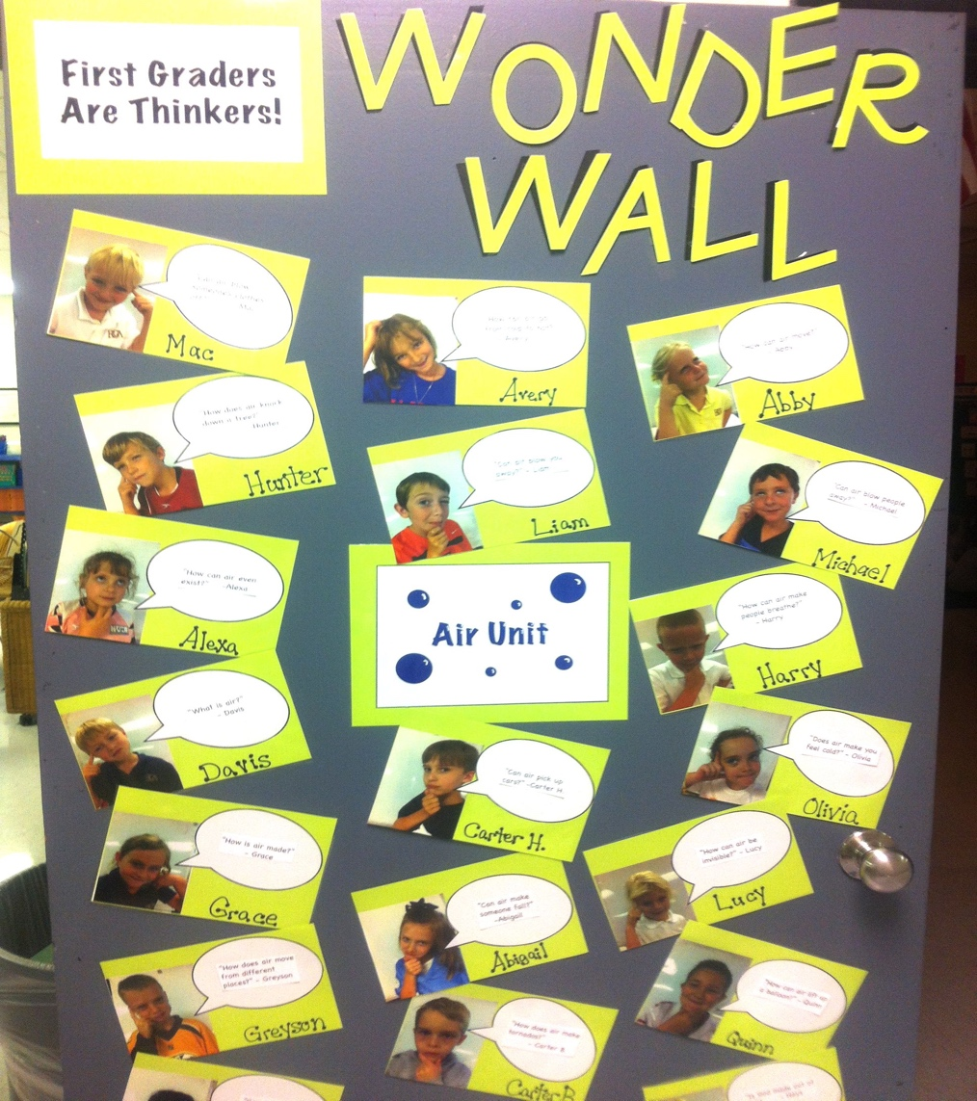
Many EYFS Pupils will have limited language and/or communication skills so modelling of this skill is important. Don’t think it’s a waste of time – you ‘seed’ what we want, expect and will, when they are ready, invite.

A useful tool for both Discern and Respond questions is a Wondering Wall. This wall provides a place to visually ‘post’ questions and responses and thus keep them active in mind and thought. It also allows you to model the process of wondering with your own questions as you encourage children to wonder themselves in an ‘I do, we do, you do’ pedagogy. Finally, it reminds us that some questions may be tricky or impossible to answer, even by grownups!

Discern and Respond questions are included in the planning tables, in Pink and Blue writing.

Focus Question 1: What happened after Jesus died and rose again? (Hear Lens)

Key Information for Teachers:
A lot happens in the weeks after the death and resurrection of Jesus. These events are remembered in two feast days (Ascension and Pentecost) that we celebrate in the Season of Easter, which begins on Easter Sunday and ends on Pentecost Sunday.

The Resurrection:
The seemingly unbelievable words of the women are affirmed not only by Peter but by what happens in the days and weeks that we remember in the Season of Easter.

After the Resurrection.
- Jesus appeared to people: The walk to Emmaus.
If you did not share the account of Jesus’ appearance to some of the disciples on the road to Emmaus (Lk 24:13-35), do that before you move on. The text is quote long – I have made some small adaptation to Luke’s actual account to make it more accessible. There is a suggestion in the resources about engaging in a conversation about why the disciples didn’t recognise Jesus. This video might be useful: https://www.youtube.com/watch?v=RI5mTW45MGA

- Jesus ascended beyond the clouds: The Ascension
The text describes the moment when Jesus gave up his earthly body and returned to the God he was – a pure spirit. Use of the term heaven, to mean the place where God is, will be literalised by children, who will think that it is a physical in the clouds. If you can, encourage them to understand the word as meaning where God is…. And that means, even your classroom!

- The Holy Spirit came to the disciples: Pentecost
Jesus would have celebrated Pentecost each year; it is the Jewish festival of thanksgiving for the harvest. People would choose their best food from their gardens and farms, mark them with red ribbon and take them to Jerusalem, the Temple, as a gift of thanks to God! You may find images of the Temple useful in working with this text.

- The early community gather
The coming of the Holy Spirit is the stimulus for the early followers to gather and talk about what has happened, and to try and live as Jesus modelled for them. Perhaps with reception children, connect the four passages that show the breaking of the bread: Mark 6 – the feeding of the 5000; the Last Super; the walk to Emmaus and the actions of the early community.

RED Content HEAR Lens | PSE | Expressive Arts and Design | Communication  and Language | Physical Development | Literacy | Knowledge and Understanding | Maths | Understanding The World
We HEAR  Jesus met some of the disciples after his resurrection (Emmaus)  Jesus went back to his Father. (ascension)  He sent a special friend, the Holy Spirit, to look after us.  Story of Pentecost (Simple Telling).  The early Christian community (Acts 2:42-47). | Emmaus:  The disciples didn’t recognise Jesus when he came to them. Talk about how some feelings can make you feel so sad it is like being covered with a cloud that you can’t see through (image in resources as example)  Wondering Wall:  I wonder who I talk to when I feel so sad?  I wonder if I have had to say goodbye to someone I love? | Ascension:  Use craft materials for clouds, sky, Jesus and the people watching to make a collage of the ascension.  Pentecost:  Have pupils draw or make their favourite fruit or vegetable out of clay or playdough, tie a red ribbon around it and take it to a very special place of prayer in your school (if you can) | Role play all of these passages: they are easy to work with – clear characters, defined movement and good settings.  Set up concrete materials to allow children to retell them.  Wondering Wall:  I wonder which passage makes me feel close to Jesus? | Emmaus: the disciples moved away from Jerusalem, but after their meal with Jesus they went back there. Thinking of the mood of each journey, have pupils show how could they have travelled each way – slowly and drudgingly; skipping and hopping?  Pentecost:  The spirit was like the rush of wind. Give the children streamers of fabric to rush among each other and around the school… | Develop an action for a key sentence from each text:  Emmaus: Don’t you know what has happened?  Ascension: Jesus raised his hands and blessed them  Pentecost:  A noise like a strong wind rushed around them  Early community:  They gathered for the breaking of the bread | START 2:  Recap the life of Jesus so far; if you did not tell the account of the walk to Emmaus do it now. (See KIT above)  AFTER Emmaus Ascension: read the account of In Resources.  AFTER Ascension  Pentecost: Read the account of the Coming of the Holy Spirit at Pentecost (In Resources)  After Pentecost:  Read about the Early Christian Community. | Early Community:  After Pentecost and the coming of the Holy Spirit the very early followers of Jesus met in each other’s houses, talked about Jesus and broke bread together.  Cutting, sharing, dividing activities.  Wondering Wall: I wonder where I see the Church doing these things now? | START 1.  Draw a chalk timeline outside.  Make a sign for each event: Jesus died; Jesus rose to life again!; Jesus met with his disciples; Jesus left the world; the Holy Spirit came; the disciples began gathering to talk about Jesus and break bread together.  Have children stand along the line…what has just happened? What is going to happen next? Take photos of them at each point holding the sign and make a visual timeline in your room.

Focus Question 2: What beliefs do Catholics remember in the Season of Easter? (Believe Lens)

Key Information for Teachers:
The events of the Easter Season hold a number of significant beliefs: notably, they affirm the resurrection, the coming of the Holy Spirit and the very first steps of the community which would grow and develop into the Church. Use the belief statements to present belief associated with this season.

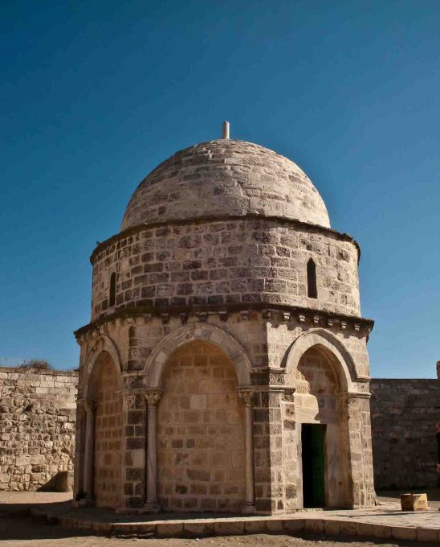
The Ascension doesn’t have a clear symbol, however, the Chapel of the Ascension in Jerusalem might be one we could turn into a symbol. The Chapel has a distinctive shape which could be useful: it raises our eyes to the top – reminding us of Jesus leaving the world to become a spirit again.

Belief Box!
As well as talking about the beliefs as you work with the content build a Belief Box for your prayer table.
The beliefs expressed in each half term are provided on the EYFS page so you can print them off and laminate them and put them into your Belief Box for later use.
Use them in prayer and collective worship; to connect to Bible passages, to connect ideas and to reinforce vocabulary. The image should hint at the belief and allow children to recall what they learned. Add to your beliefs each half term to keep what Catholics believe ‘fresh’ and alive in the children’s minds.

RED Content BELIEVE Lens | PSE | Expressive Arts and Design | Communication  and Language | Physical Development | Literacy | Knowledge and Understanding | Maths | Understanding The World
We BELIEVE  After his life, Jesus left his body and became a spirit again  The Holy Spirit came to the community at Pentecost  The Holy Spirit is our friend. The Holy Spirit looks after us.  The early community lived out the Good News of Jesus | Emmaus: Have pupils trace around their feet (twice) and make two sets of feet: left and right. Decorate one with a pair of sandals for Jesus and one with school shoes as their own feet. Match left and right feet and make tracks of Jesus walking with the children.  Wondering Wall  Jesus walks with me. I wonder what I say to him? | Ascension craft: see link below. | The early community talked about what Jesus and broke the bread together.  Wondering Wall:  If Jesus came and sat at lunch with me, I would talk to him about…. | You can’t see or touch the spirit of God, so we try and say what it is like. We talk about the spirit being like fire or wind or breath.  Have pupils blow, wave or run with bubbles ….show the way the spirit is in the world. | Have pupils make a Pentecost windmill (link below) use words like cut, fold, colour, turn, pin, blow.  Have pupils draw the scene of the coming of the spirit on the base square of the windmill. | 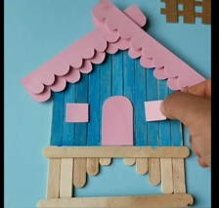  The early community met in people houses. Make houses with icy-pole sticks – don’t forget they had flat roofs!  Find images of houses on the Nazareth Village website. | Explain that a chapel (place of prayer) have been built where people think the Ascension happened: show children a picture (KIT above) and have them make the chapel with shapes: rectangles and semi circles and arch windows. | Use the Belief slides (PP) to build your set of beliefs.
https://www.amazon.com.au/Jesus-Ascension-Craft-Kit-Activities/dp/B006VXZD0C – don’t buy; make your own!
https://www.easy-crafts-for-kids.com/paper-windmill.html - windmill instructions.

Focus Question 3: How did news of Jesus’ resurrection go into the world? (Celebrate Lens)

Key Information for Teachers:
The short story of the events that you are remembering and teaching is that the resurrection, prompted by the coming of the spirit, resulted in the beginning of a community which over hundreds of years, has become the Church as we know it.

A couple of things are important: Jesus founded the church in the sense that he inspired and laid the foundations in his teaching and actions. He didn’t write a policy document for its development or even write down a set of rules for its structure or actions. His life, remembered by the earliest and later followers, was the inspiration for the Church then, and now.

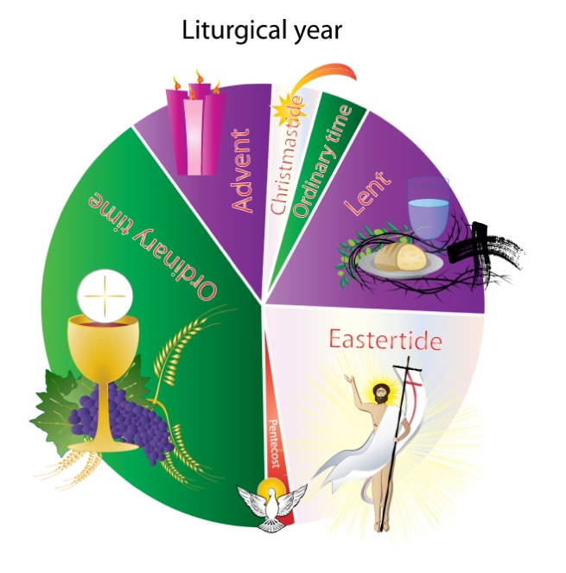
Second, the Church as we know it – the one that goes to the ends of the earth – has changed and developed over a long period. Your timeline will hopefully enable you to build a sense that the Church as we know it did not start immediately, rather it emerged and continues to emerge in response to the signs of the times. What we do now in celebrating these events has taken hundreds of years to develop – and in a hundred years from now, we may be celebrating them differently.

The Season of Easter provides great opportunity for playing with colour!
The main colours of the Season are white and gold; however Pentecost Sunday is red and after Pentecost (so the colour of the early community), is Green.

RED Content CELEBRATE Lens | PSE | Expressive Arts and Design | Communication  and Language | Physical Development | Literacy | Knowledge and Understanding | Maths | Understanding of the World
We CELEBRATE  Pentecost is a special celebration in the Church. Sunday is a special day for the Church to celebrate.  The parish church is a special place where we meet our friends. We sing and say prayers.  We gather with friends at church, especially on Sunday. (Live) | Write and say prayers for people in your Parish/es: pray for the leaders of the parish, people in the school/s; people being baptised; people who are sick, sad or who have died etc. A newsletter will tell you what is happening in the Parish at the moment. | Make a train set for children to sequence: one event per carriage. Have them decorate each carriage with the  event, its symbols and colours. (see resources) | Talk to Year 2 – they are leaning about the fruits of the Spirit. Make a spirit tree with the fruits. Wondering Wall  I wonder what fruits of the spirit I see in my family and friends? | Set up your outside area as a place the disciples could sit, talk about Jesus and break bread together. | Each Mass begins with a prayer called the collect. Use part of the collect for your class prayer.  Pentecost:  ‘pour out, we pray, the gifts of the Holy Spirit across the face of the earth’  Ascension:  ‘Gladden us with holy joys’  Emmaus:  ‘May your people praise you forever’ | Find photos of your parish church/es.  Place them in the middle of a poster/display and have children draw or paint families singing and praying. (They may or may not draw their own family). | START:  The tone of the Season of Easter is like that of Spring: warm, joyful, and full of life.  Make flowers using the colours of this season: green leaves, white, gold and red petals.  Put the name of the child in the centre of the flower head | Some people call Pentecost the birthday of the Church as it is the event on which the community that would become the future church, was born.  Make birthday signs, candles, hats, banners – and decorate them with symbols of the coming of the spirit – wind and fire.

https://www.holyart.com/blog/church-supplies/the-liturgical-year-let-us-clarify/

Focus Question 4: How can we live as the people of God now? (Live Lens)
Key Information for Teachers:
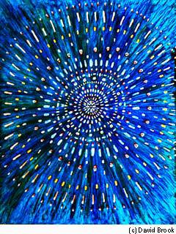
The principle of CST in this half term reminds us that all people are God’s children. Through baptism some will become members of the Christian Church. However, we can and should celebrate the life of God in all people – baptised or not.

Deuteronomy (14:1) says that each person is precious because God created everyone with God’s own divine spark.

ttps://www.chabad.org/library/article_cdo/aid/676238/jewish/Individuality-and-the-Divine-Spark.htm

RED Content  LIVE Lens | PSE | Expressive Arts and Design | Communication  and Language | Physical Development | Literacy | Knowledge and Understanding | Maths | Understanding of the World
We LIVE  CST We Are Called to Live as Family and Community.  CST All people are God’s children. That makes us brothers and sisters. | Do some dot rock painting. https://www.google.com/search?q=dot+rocks+painting&tbm=isch&ved=2ahUKEwi2i8zf5PWEAxUqomMGHSrpAWMQ2-cCegQIABAA&oq=dot+rocks&gs_lp=EgNpbWciCWRvdCByb2NrcyoCCAEyBRAAGIAEMgUQABiABDIGEAAYBRgeMgYQABgFGB4yBhAAGAUYHjIGEAAYCBgeMgYQABgIGB4yBhAAGAgYHjIGEAAYCBgeMgYQABgIGB5I8xVQ_gJY_gJwAHgAkAEAmAG1AqABgASqAQUyLTEuMbgBAcgBAPgBAYoCC2d3cy13aXotaW1niAYB&sclient=img&ei=W_7zZfbxK6rEjuMPqtKHmAY&bih=703&biw=1402  The message is simple and covers every area: all people are God’s children: we all carry God’s divine spark within us.  Have children dot some rocks with patterns to show God’s spark – use appropriate colours – in them. Use the image above to stimulate art that tries to show the movement and vitality – the spark – of the divine spark.  Place them in a prayerful place to model care, respect and our unity as the whole family of God.  You can buy special dotting tools or use the flat end of a pencil or cotton buds. You can also do dot painting on surfaces other than rocks.

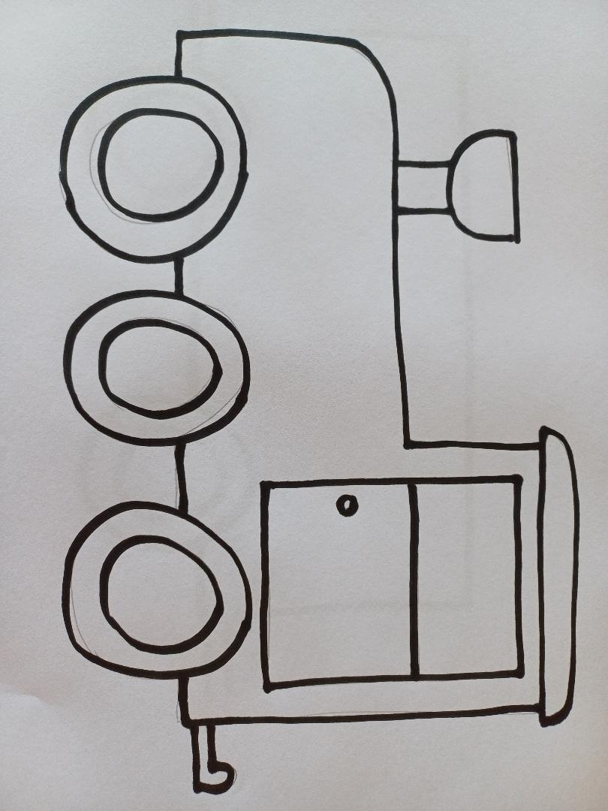
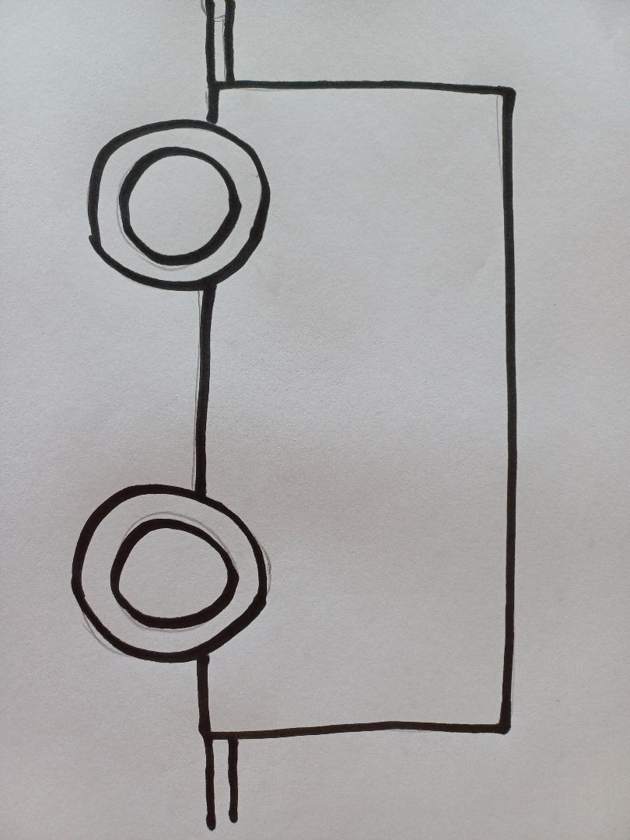
Resources:

Train sequence

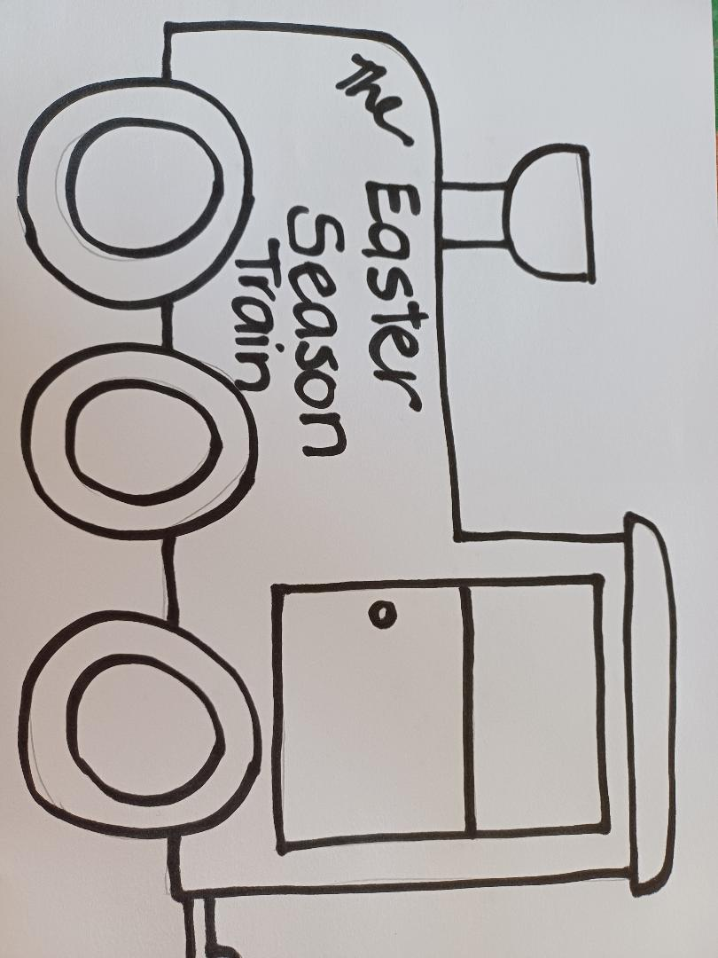

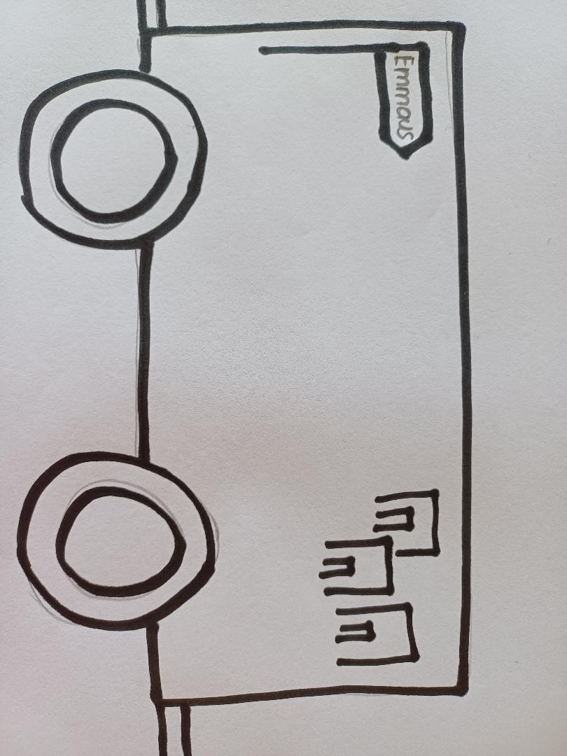

Emmaus – the disciples didn’t recognise Jesus

What feelings can feel like a cloud hanging over your head?
Maybe the disciples felt that way – they were so sad and upset that they didn’t know it was Jesus…. until he sat with them and did what he did in his life… broke the bread and gave it to them!

